SUPPLEMENT LIVYANI 1.0

This is an optional module covering the use of the Livyani army in Kenengdalikoi. The Livyani forces have a number of key differences in their operation from the other armies of the Five Empires.
They are organised in Lluneb (legions) and Charoneb (regional groupings of legions). Each Charoneb has a specific legion of magic users (Diodaz) , which are generally combined with normal troops. These Diodaz very different their function to standard CPs. They are the core of the Livyani army, with massive magical capability, including a range of Livyani Powers of the Planes (LPOPs) using Livyani Powers SSS (LPSSS) granted only by their Shadow Gods.

The Diodaz can move around like normal units, and indeed fight, with no impact on the magical powers. These latter come in three flavours - SSS, PSSS and LPSSS. However to use these LPOPs the Diodaz are required to be close to the line of combat (if not actually in it) since their ranges are short. The Diodaz can be attacked with missile fire and meleed, with the usual unhappy consequences.
Diodaz can use PoPs on themselves when in contact such as Lascivious Embrace

DIODAZ - command points, magic, ability to fight, move

The SSS and PSSS of the Livyani are operated by the Diodaz. These are magic user legions which are part of each Charoneb.

Unlike the other empires these Diodaz have significant conventional combat capabilities. However, their many purpose is to get close to the enemy units to use their special short range PoPs to disrupt the enemy battleline.

Each Diodaz has its own allocation of SSS and PSSS. These cannot be used to command units attached to a different Diodaz, cannot be transferred and any losses are taken in the relevant Diodaz only. Artillery can be commanded by any Diodaz but they cannot share the costs of a single artillery command.
Moving Diodaz costs 3 x SSS (so 9 if issued as last command of turn). Other costs are standard so 1 for first command, 2 for second etc. However, there is no reduction in SSS or PSSS.

Diodaz are all classified as medium but can accelerate to Pe Choi pace by casting Cabbalistic Rites of Entry unto the One of Fears as well as a move command.
Diodaz can cast commands, PoPs and LPoPs when in contact with enemy (ie melee).

Diodaz will typically be a bit short of SSS, standard on PSSS but also have LPOPS, so three things needs to be tracked.

THE POPS OF THE SHADOW GODS OF LIVYANU (LPOPS)

In addition to the standard PoPs available to the lesser priests of the parvenu empires Livyani Diodaz have a range of additional LPoPs). Each Diodaz also has an allocation of LPSSS which is limited per turn and in the game overall (as with PSSS).
Must be cast from range not more than [300] [200] so must be close to enemy lines.
When cast in contact with enemy effect enhanced.
When a counter PoP is used ie Beast countering unit rolls 2D6. GoB = counter has no effect, DaD = effect of spell countered halved. Diodaz can put LPSSS in to reduce roll on a one for one basis.
Max 2 LPOPS on any unit, but can have two PoPs and 2 LPoPs.

Description of LPOPs

Costs - All costs are shown on the LPoPs table
Range - All ranges are shown on the LPoPs table
Duration - All durations are shown on the LPoPs table

CABALISTIC RITES OF ENTRY UNTO THE ONE OF FEARS

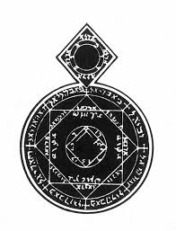
Effect: Diodaz moves at speed of Pe Choi
CHIMING ANKLETS OF KIRRINEB



Effect: 30% off CBSSS of target CP for turn
CLANDESTINE PATHS OF DESTINY

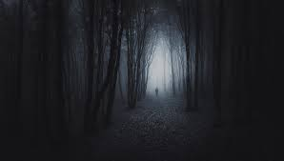

Effect: Attacked CP may be moved by Livyani 300mm, not nearer to enemy, which costs it 50% of CBSSS (or all if 50% not available).
CONCEPTS OF DECEPTIVE HORROR



Effect: Livyani unit becomes Fanatical

CONSTRICTING FIBRES OF DEATH BY VRAOZ

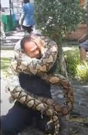

150mm zone round friendly legion projects FMZ

CRYPTIC CONCERNS OF THE ONE OF SHADOWS

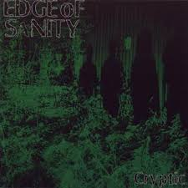

Effct: Enemy unit rolls randomly (D20)for Form change. If it changes to an non permitted formation then its melee attack multiplier = 1. This counts as one of three commands / turn.
In Contact: If in contact roll -4 form change QC, GoB = Melee CH

DISSEMBLING EVASIONS OF VRUSAEMEZ

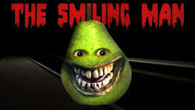

Effect:

The unit on which this is cast is removed from the board. However, it can still be given Move, Recover and Formation Commands. When it moves the owning player should track it using any cunning means that comes to mind. Its move is subject to the usual constraints of distance, terrain, facing etc. However, it ignores any enemy close zones but may NOT move through an enemy unit. Should an enemy unit move so that it would be in contact with the Vrusaemez unit then place the Vrusaemaz back on the board with the correct facing and halt the movement of the enemy unit 50mm away ie placing the invisible unit in the FMZ. The unit is considered to have standard width so no sneaking through tiny gaps!

ESOTERIC DOCTRINES OF PHANTASMAL TSAMRA

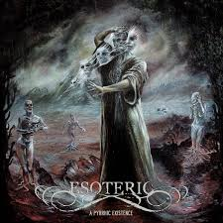

Effect: Attack CP, 30% off Global Allocation of PSSS for turn
FLICKERING TOUCH OF RU’UNGKANO

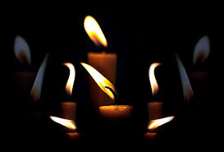

Effect:

A light Livyani unit may be given flight by this LpoP. It can then be issued a Move Command which allows it to either:

Move to contact a Hlaka triad and attack it on the Hlaka table with -2 modifier. Any A result means the Hlaka is permanently removed.

Or it may move to any enemy unit and be given to two Fire Commands allowing it to fire at that unit from close range with a formation multiplier of 2.

In both cases the unit returns to its original location at the end of the Cycle.

GLOOMY OBELISK OF QUYOVE

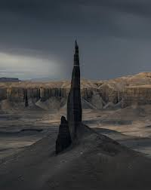

Effect: Enemy unit moves half speed
HERMENEUTIC READINGS OF THEOLOGICAL CONCERN

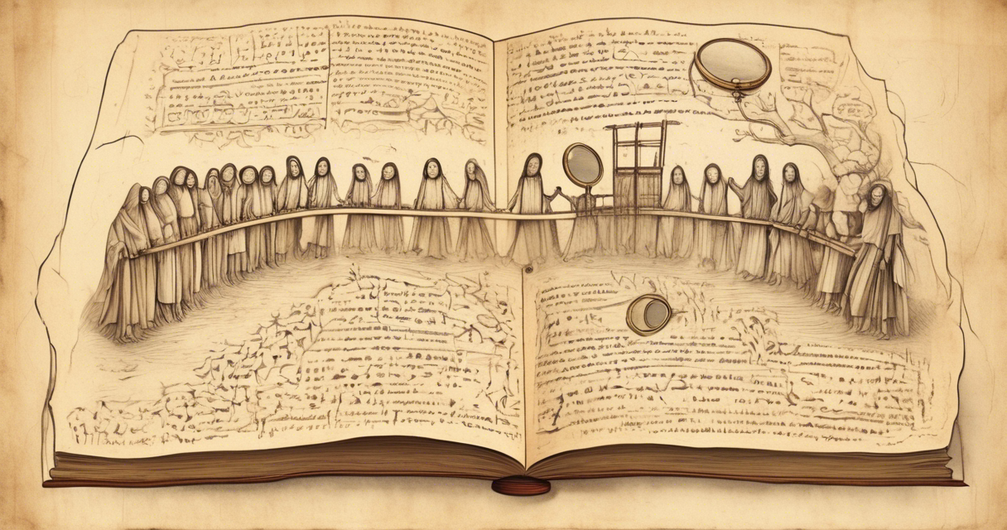

Effect: Unit has - 6 bender to receive order
Counter: Cleansing Blade

HERMETIC DECEPTIONS OF DUMUZ ASQAR



Effect: Can issue any order to enemy unit, one of three. If a move order is issued then may move it.

HIDDEN MYSTERIES OF UNKNOWN BEING



Effect: Double speed of unit

INEXPLICABLE JOCOSITIES OF KIKUMARSHA

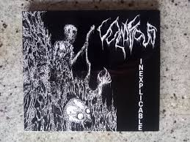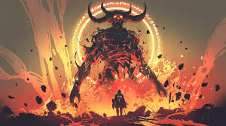

Effect:
A unit of demons is created within range (Acephalous Tsuhugir etc) and remains for two turns. Look out the appropriate unit card. Once a given type of demon has been summoned it cannot be summoned again. Demons summoned can be either:

Ground based in which case the unit may be given two commands only - Move and Contact. Their formation is chosen when they arrive, may be anything permitted to an equivalent human unit on the Formation table and may not be changed.

Or:
Flying in which case they can be give Fire Commands (twice / turn) and Move Commands.

Move commands permit them to move any distance over the battle to shoot at a ground based unit (treat them as directly over the unit) or to make contact with a Hlaka triad. In this case they then roll on the Hlaka table with +1. Any A result causes the permanent removal of the Hlaka triad. An A1,2 or 3 result permits the Demons to immediately move to another triad and repeat the process.

Fire Commands permit them to fire at the unit they are directly above only. They can decide when placed what range they are firing at and cannot change it. If the Keneng wants them to fire at a different unit they must be given a Move command first. Their formation multiplier for fire combat is 1.

The commands given to the demons cost SSS in the normal way. This must be paid by the summoning Diodaz. A given Diodaz can only summon demons once / battle [review depending on play balance].
A flying demon unit can be fired at by missile units including ballistas. Range is the horizontal distance to the demons plus 201mm (so short range becomes medium etc).

OBSCURE DOCTRINES OF TSAQW

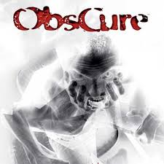

Effect: Unit ignores shaken / disordered mods

PEREGRINATION TO KIRRINEB'S EMBRACING ARMS

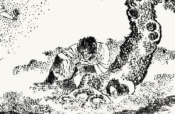

Effect: Battle Frenzy, Unit has + 6 to melee attack
In Contact: Bender is +8

QUINTESSENTIAL MYSTERIES OF THE SHADOWS

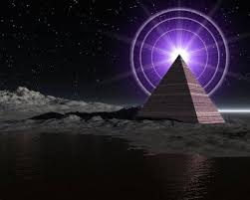

Effect: A light unit (only) may become invisible and while invisible pass through one enemy unit. Having passed through it becomes visible if it receives another command or it if it comes into contact with an enemy unit.

SABLE VEIL OF KIKUMARSHA



Effect: Diodaz (only) -6 bender if missile attacked
Counter: Hideous Visions?

SLOW DEMISE OF THE CULPABLE RECUSANT



Effect:
In Contact: Unit also is -6 on Melee Attack roll

SUBTLE CONCATENATIONS OF NDARKA



Effect:
A Livyani unit in open order is able to pass through the enemy unit on which this is cast ignoring it and its Close Zones. It can be cast on any enemy unit in range, even one in melee.

SUSSURATING TIDES OF LAIGAS



Effect: MZ and FMZ from target unit count as CZ only

TREACHEROUS SHOALS OF SHENGELU

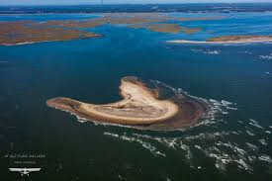

Effect: Enemy unit must move directly towards and attempt to contact nearest LIvyani unit, gets + 2 when it attacks. Livyani unit may not be more than 400mm away.

UNEASY ANGST OF THE UNBELIEVER



Effect: Enemy unit shaken even if zero CH taken
UNKNOWN UNSEEING OF SHADOW



Effect: Target Unit cannot move.
Counter: Beast without a Tail

WEB OF UNNAMEABLE FEAR

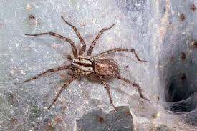

Effect: Enemy unit gets an automatic free reface to rear and must retreat full move, ends up facing away.
In contact: If from melee take 1 x Missile CH as well
Diodaz without military capability

Do xxx
Longer range
Can still be missiled and meleed
So need recovery ability which takes SSS
Move using SSS, same movement ability as standard Diodaz.

EFFECTS OF SHAKING / DISORDERING ON SSS / PSSS

Down 10% on each when disordered, 30% shaken

HLAKA AND AIR CARS

The Livyani have no access to Hlaka so never use them in combat. However, they do have some old air cars which perform similar functions. These air cars can:

Bolt of Metallja (Bolt) - Intercepting

Air Cars on Bolt perform the same as Hlaka. However in combat they attack on +4. If they roll 2, 3 or 4 (unmodified) they are disabled for the rest of the battle.

Eye of Subadim (Eye) - Reconnaissance

They perform all the standard Eye functions. They can be attacked by Hlaka but the Hlaka have no effect on them. However, the air cars must fire back at the Hlaka with a net modifier of 0. If they roll 2 or 3 they are disabled for the rest of the battle

SWAMP folk same as hogs in marshes

